**SUBMISSION FOLDER**

Create new folder in your name(and date) - SJ14052023

Open SJ14052023

Create Q1 folder

Open applications and select office and office writer

Save as .doc in Q1 folder

Font: Courier 10 Pitch 16 Bold

Enter commands and attach screenshots

**CREATION OF PERMISSIONED NETWORK WITH 2 NODES**

Create new folder in your name(and date) - SJPermissioned14052023

Create 2 noded permissioned network:

Inside folder create 2 folders: node1 and node2

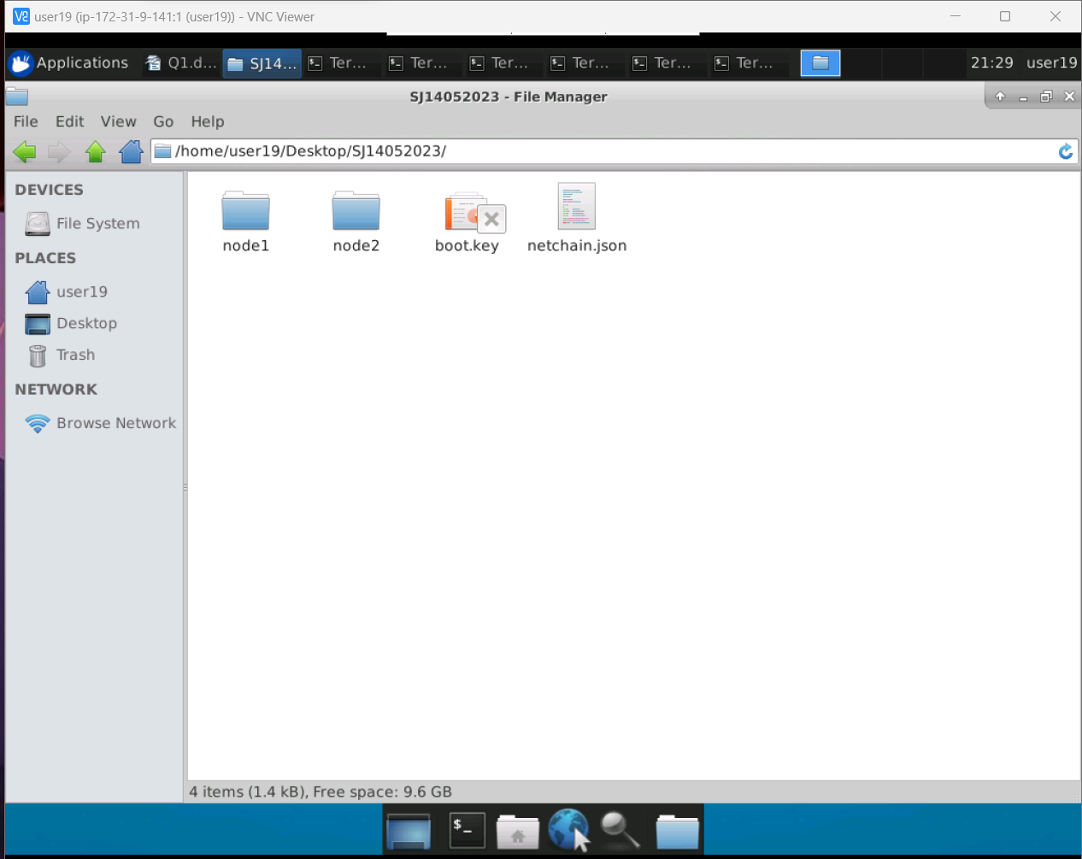

Open terminal inside SJPermissioned14052023:

* Ls
* Su ubuntu
* Paste admin password
* Sudo geth --datadir node1 account new
* Enter any password and remember it (abc)
* Open notepad in local system and paste new key generated
* Do same for node2

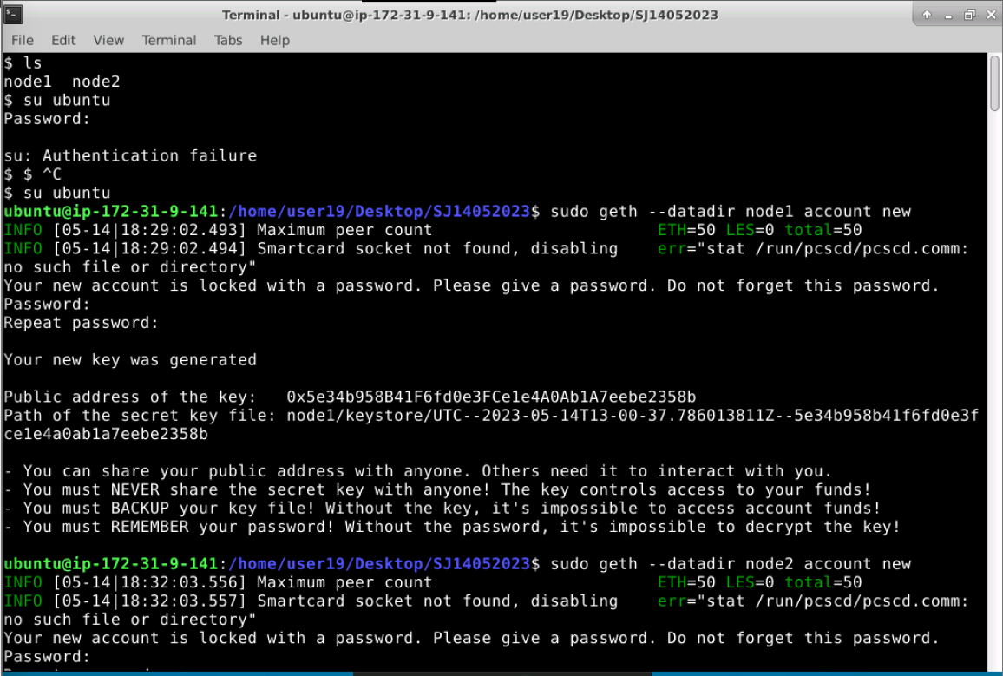

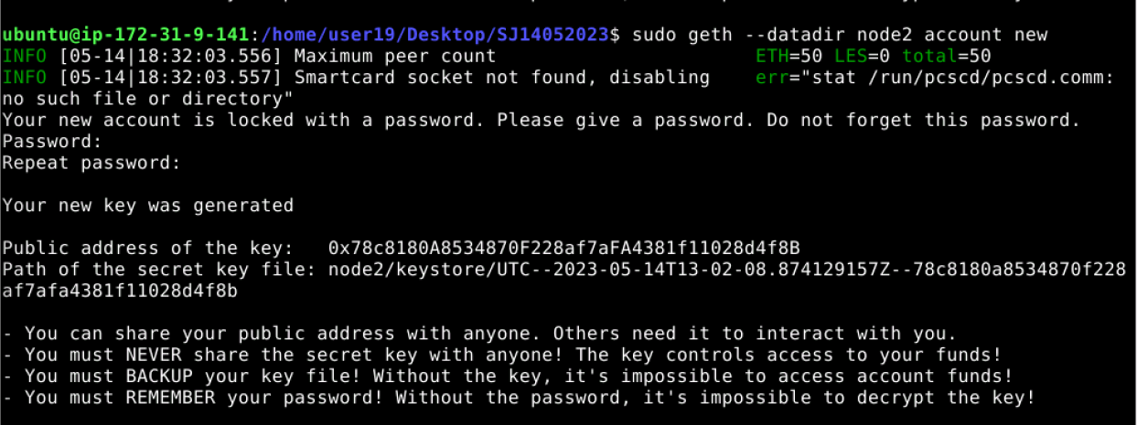

Creating genesis block:

Creating genesis.json(netchain.json) files and pasting in individual node folders

In terminal:

* Sudo puppeth
* Enter network name: (eg-netchain)
* Option 2 : Configure new genesis
* Option 1 : Create new genesis from scratch
* Option 2 : Clique POA
* 5 seconds
* Which accounts are allowed to seal: public key of account 1
* Which accounts should be prefunded: public key of account 1 and account 2
* Should precompile: press enter
* Network id : 54321
* Ls
* Sudo vi netchain.json (bring cursor to below alloc line, type 758dd and delete until last 2 objects and press enter, press esc and then :wq!(to save and exit))
* Sudo cp netchain.json node1
* Sudo cp netchain.json node2
* Sudo geth init --datadir node1 netchain.json
* Sudo geth init --datadir node2 netchain.json
* Sudo tree node1
* Sudo tree node2
* Sudo bootnode -genkey boot.key
* Sudo bootnode -nodekey boot.key -addr : 31310
* Copy enode address

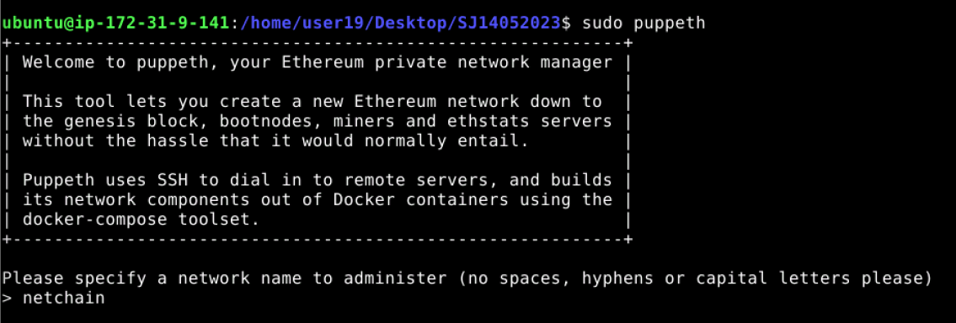

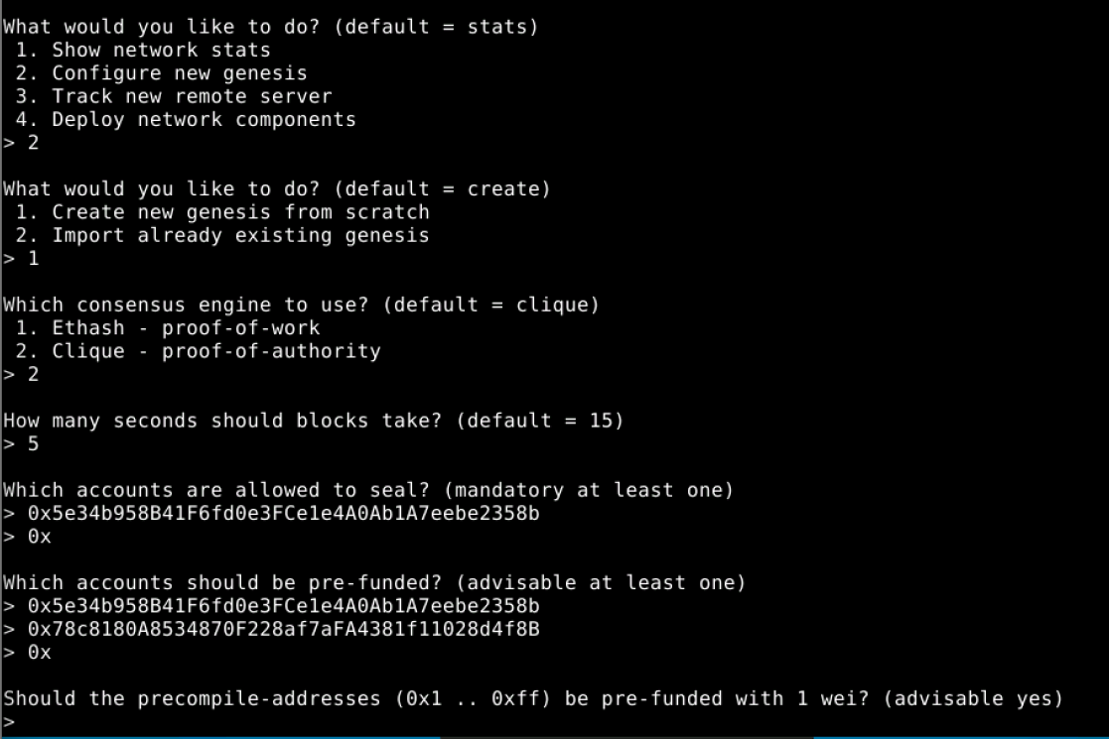

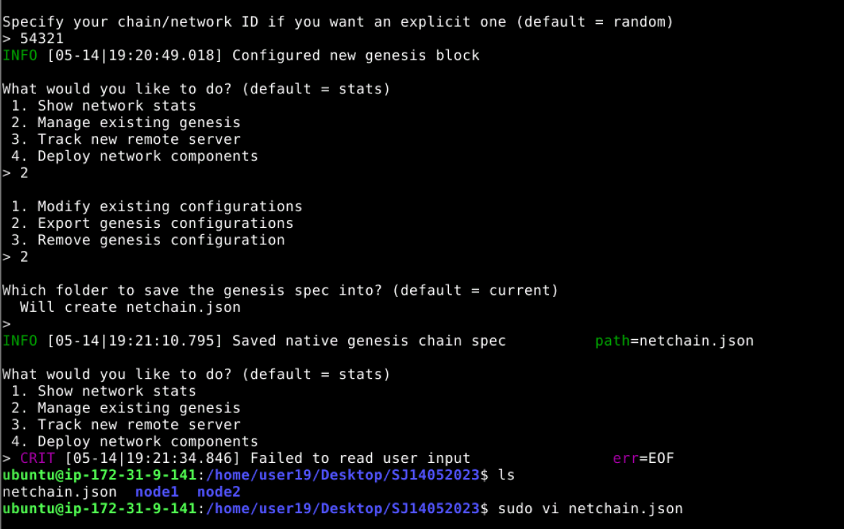

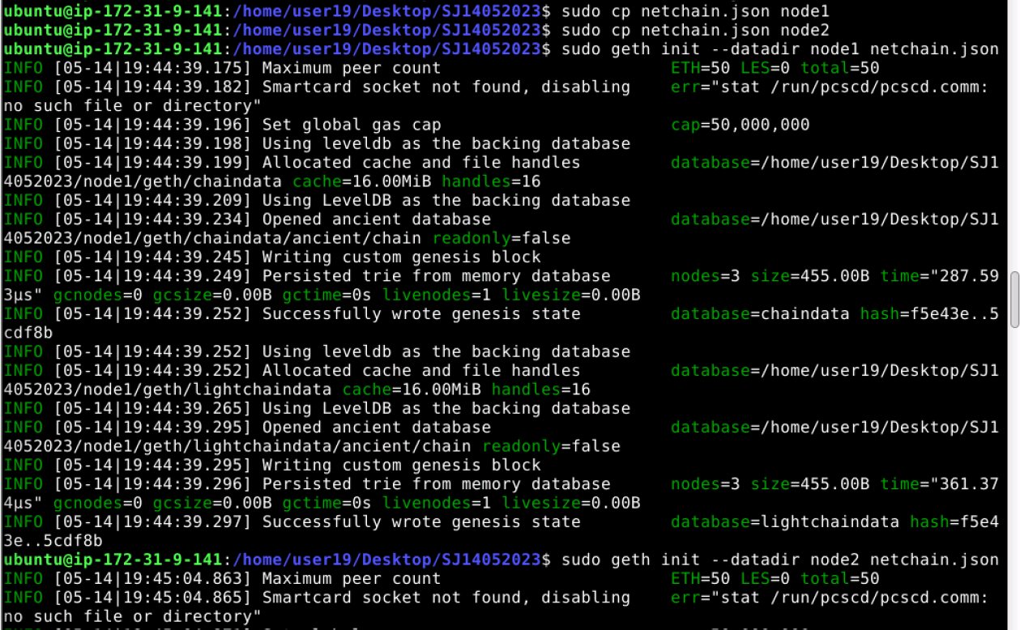

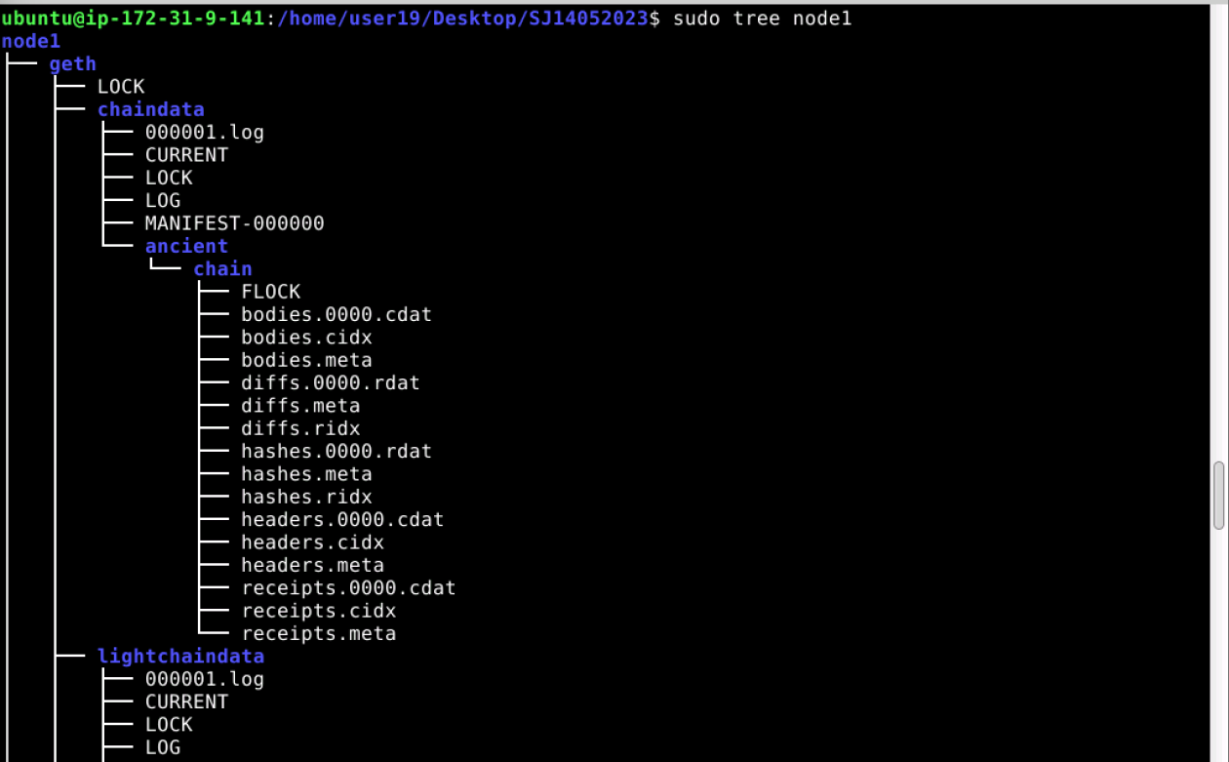

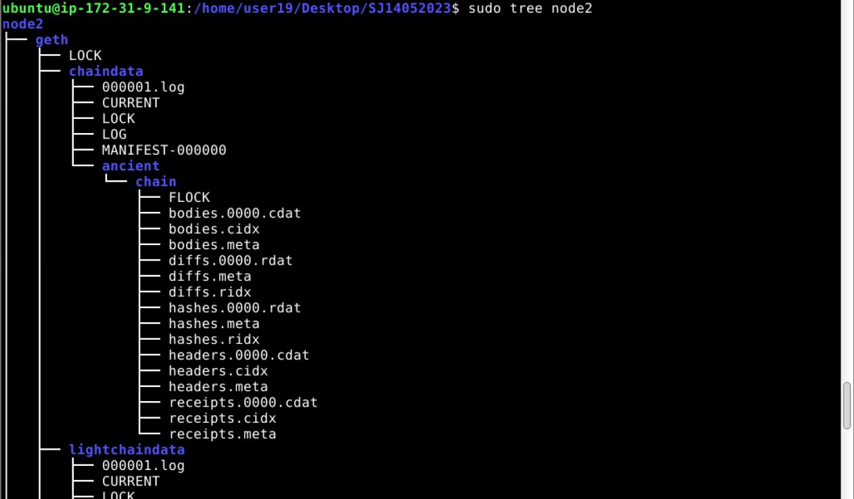



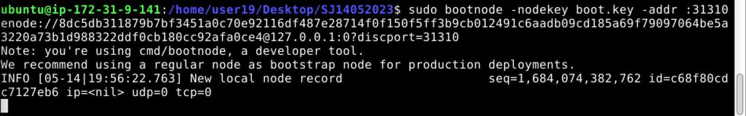

Open 2 new terminals:

* Su ubuntu
* Enter admin password
* Sudo geth --datadir node1 --port 31311 --bootnodes <enode address> --networkid <network id> -- unlock <public key account 1> --allow-insecure-unlock --authrpc.port 8554
* Sudo geth --datadir node2 --port 31312 --bootnodes <enode address> --networkid <network id> -- unlock <public key account 2> --allow-insecure-unlock --authrpc.port 8555
* Peercount in both terminals should be 1

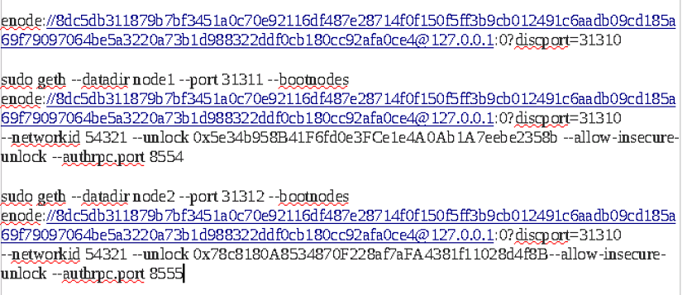

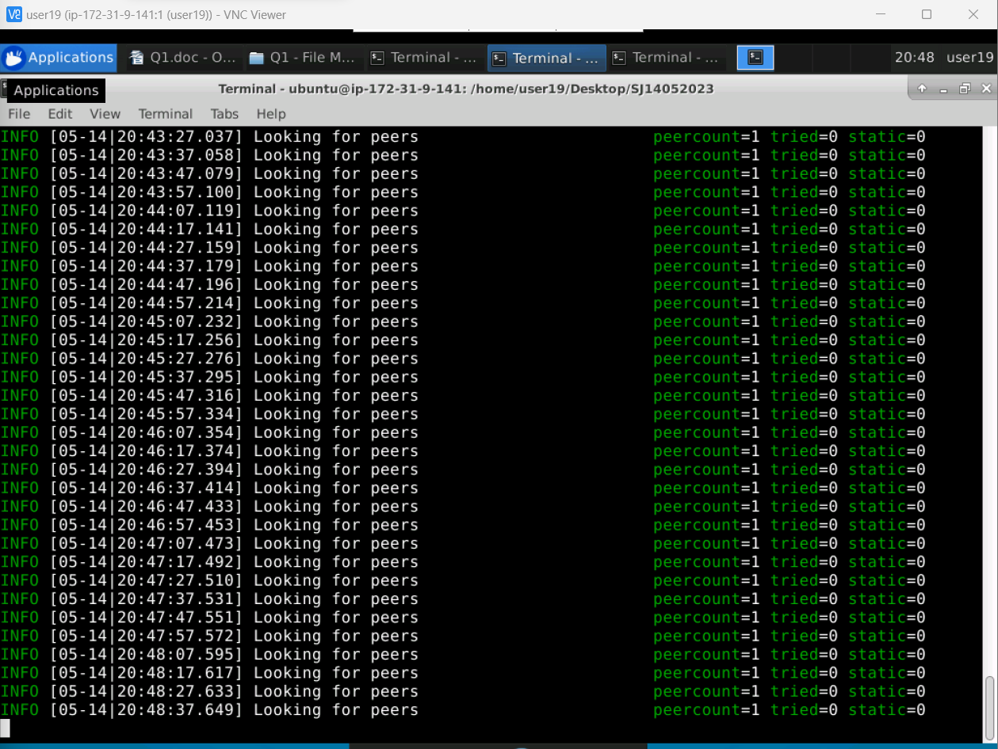

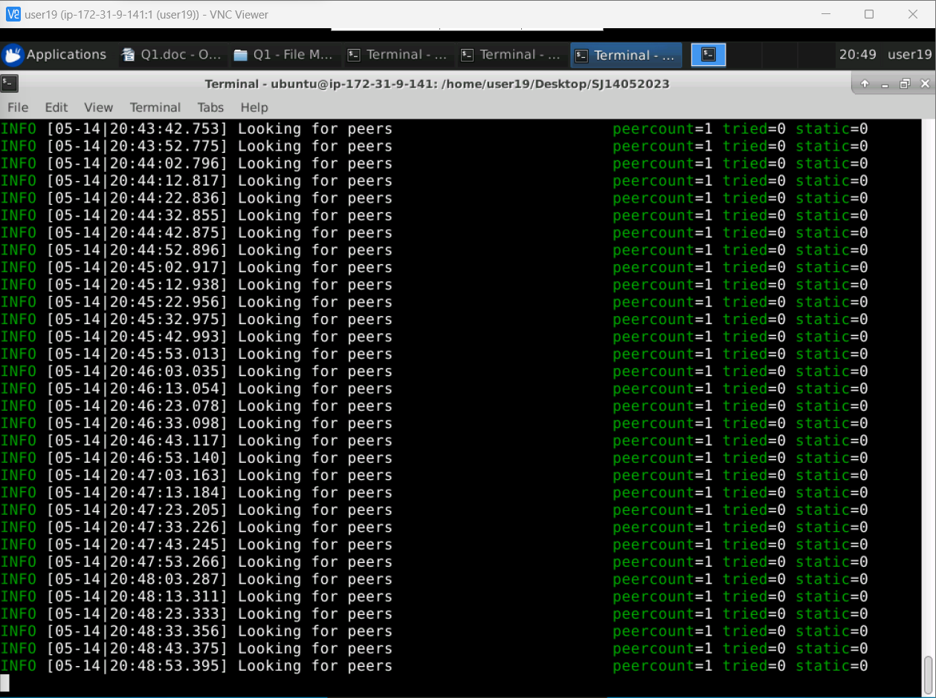

Open 2 new terminals:

* Su ubuntu
* Enter admin password
* Sudo geth attach node1/geth.ipc
* Sudo geth attach node2/geth.ipc
* Commands:
* net.peerCount
* admin.peers
* eth.getBalance(eth.accounts[0])

